Assignment 2: Work with Open Data
Dataset Chosen
- Title: Total unemployment rate (age 15–74, % of active population)
- Source: Eurostat (official EU statistics portal)
- Dataset code: tps00203
- Portal link: https://ec.europa.eu/eurostat/databrowser/view/tps00203/default/table?utm_source=chatgpt.com
- API endpoint (used in code):
https://ec.europa.eu/eurostat/api/dissemination/statistics/1.0/data/tps00203

Access Method
The dataset was accessed programmatically using the Eurostat JSON API. I used Python with the requests library to fetch the data and pandas to clean and organize it. The code runs top-to-bottom in Google Colab without manual steps.

Cleaning and Transformations
The raw JSON included multiple dimensions (freq, age, sex, unit, geo, time). I filtered for:
- freq = A → annual data
- age = Y15-74 → population aged 15–74
- sex = T → total, both sexes
- unit = PC_ACT → percentage of active population
- geo = LT → Lithuania
Then I converted the time dimension to integers (years) and sorted values chronologically.

Result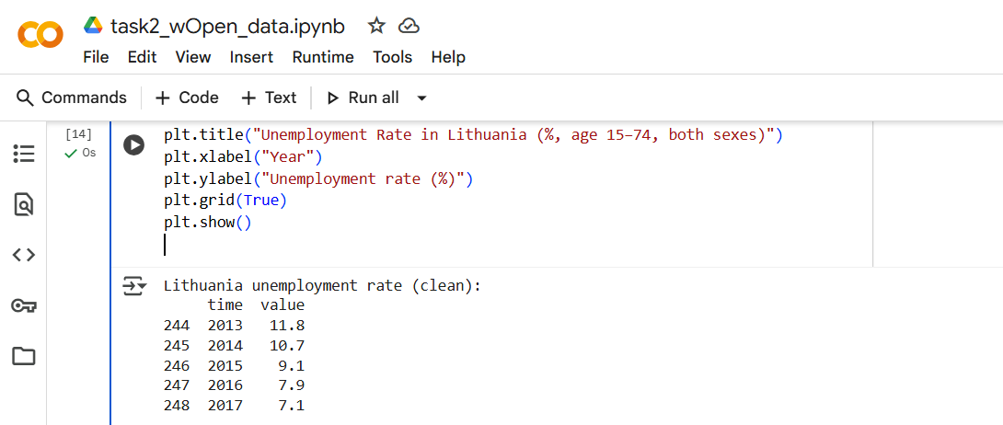
Visualization:
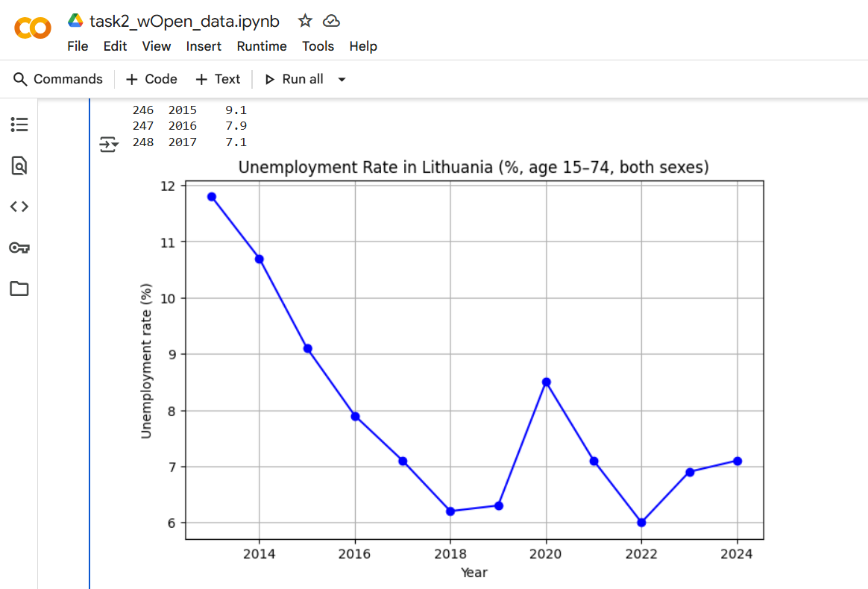
📈 Line chart showing Lithuania’s unemployment rate from 2013–2024 (age 15–74, both sexes, % of active population).

Interpretation
Lithuania’s unemployment rate has generally declined since 2013, falling from around 11.8% in 2013 to 7% in recent years. Noticeable increases appear around 2020, reflecting the impact of the COVID-19 pandemic.

Obstacles and Solutions
- Issue: Eurostat’s JSON format was compressed and difficult to parse (values indexed by integers).
- Solution: I decoded observation indexes using the provided dimension metadata and then filtered only the meaningful subset (percentages, not raw counts).

Licensing
Eurostat data is open and free to use under the Creative Commons Attribution (CC-BY 4.0) license, provided the source is cited.

